

| **TITLE : To perform NLP on clinical data** |
| --- |

**AIM:** Named Entity Recognition on Healthcare Data

**Expected OUTCOME of Experiment:**

CO5: Apply data analytics in the field of Health care.

**_____________________________________________________________________**

**Books/ Journals/ Websites referred:**

GOOGLE COLAB

Google

**_____________________________________________________________________**

**Pre Lab/ Prior Concepts:**

Students should have a basic understanding of natural language processing concepts like named entity recognition.

**Procedure:**

**Data set Used: Pretrained spaCy model**

**Step1: Installed required library**

**!pip install spacy --user**

**!pip install https://github.com/explosion/spacy-models/releases/download/en_core_web_sm-3.5.0/en_core_web_sm-3.5.0.tar.gz**

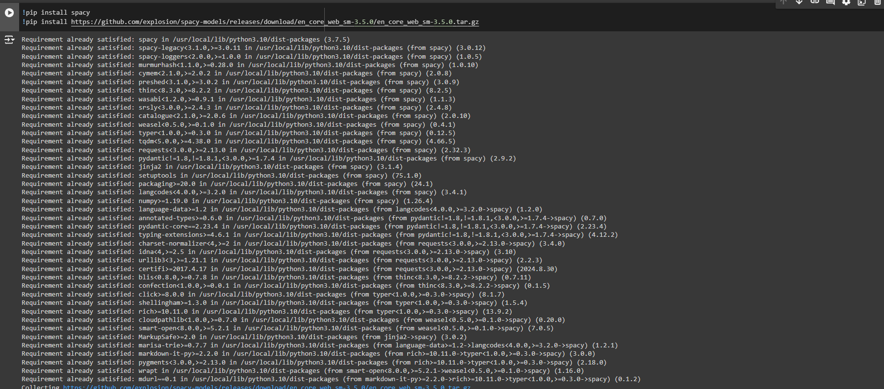

**Step2: Load pretrained spaCy model**

**import spacy**

**nlp = spacy.load("en_core_web_sm")**

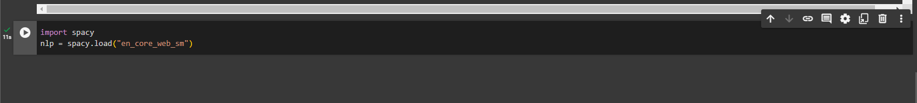

**Step 3: Add Sample healthcare-related text**

**healthcare_text = """The patient, Pinky aged 20, was diagnosed with hypertension and stage 2 breast cancer.**

**They were advised to take atorvastatin and metformin. The patient is scheduled for**

**a follow-up appointment at Mercy Medical Center on October 31st.**

**The patient reported severe headaches and fatigue.**

**She also received a prescription for chemotherapy regimen.**

**"""**

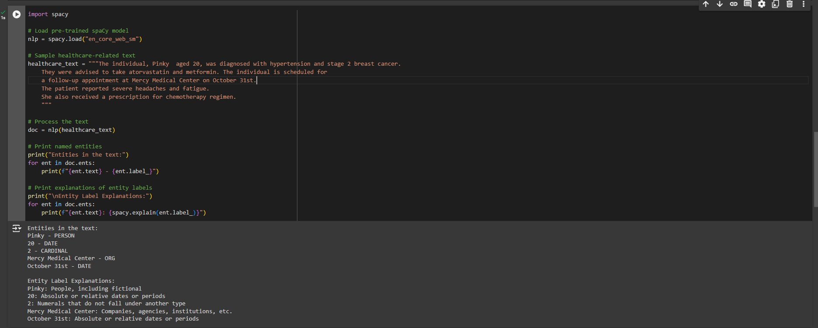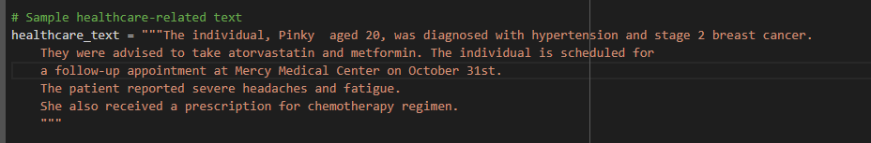

**Step4: Process Text**

**import spacy**

**# Load pre-trained spaCy model**

**nlp = spacy.load("en_core_web_sm")**

**# Sample healthcare-related text**

**healthcare_text = """The individual, Pinky aged 20, was diagnosed with hypertension and stage 2 breast cancer.**

**They were advised to take atorvastatin and metformin. The individual is scheduled for**

**a follow-up appointment at Mercy Medical Center on October 31st.**

**The patient reported severe headaches and fatigue.**

**She also received a prescription for chemotherapy regimen.**

**"""**

**# Process the text**

**doc = nlp(healthcare_text)**

**# Print named entities**

**print("Entities in the text:")**

**for ent in doc.ents:**

**print(f"{ent.text} - {ent.label_}")**

**# Print explanations of entity labels**

**print("\nEntity Label Explanations:")**

**for ent in doc.ents:**

**print(f"{ent.text}: {spacy.explain(ent.label_)}")**

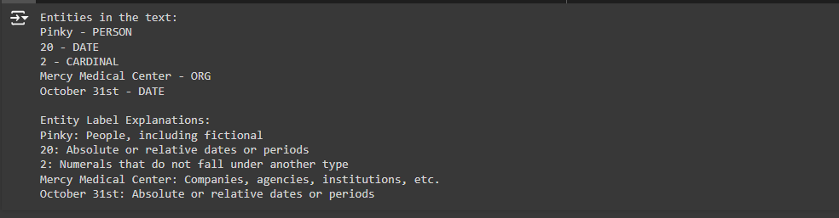

**Step 5: Print named entities**

**# Sample healthcare-related text**

**healthcare_text = """The patient, Pinky aged 20, was diagnosed with hypertension and stage 2 breast cancer.**

**They were advised to take atorvastatin and metformin. The patient is scheduled for**

**a follow-up appointment at Mercy Medical Center on October 31st.**

**The patient reported severe headaches and fatigue.**

**She also received a prescription for chemotherapy regimen.**

**"""**

**# Process the text**

**doc = nlp(healthcare_text)**

**# Define custom entity labels for diseases, drugs, symptoms, and persons**

**disease_labels = ["type 1 diabetes", "cancer", "hypertension", "stage 2 breast cancer"]**

**drug_labels = ["crocin", "lisinopril", "paracetamol", "atorvastatin", "metformin"]**

**symptom_labels = ["severe headaches", "fatigue", "shortness of breath", "persistent nausea"]**

**person_labels = [ "patient","doctor"]**

**future_prescriptions = ["insulin therapy", "blood pressure medication","chemotherapy regimen"]**

**# Iterate through the text and identify entities based on the custom labels**

**entities = []**

**for label in disease_labels:**

**if label in healthcare_text:**

**entities.append((label, "DISEASE"))**

**for label in drug_labels:**

**if label in healthcare_text:**

**entities.append((label, "DRUG"))**

**for label in symptom_labels:**

**if label in healthcare_text:**

**entities.append((label, "SYMPTOM"))**

**for label in person_labels:**

**if label in healthcare_text:**

**entities.append((label, "PERSON"))**

**for label in future_prescriptions:**

**if label in healthcare_text:**

**entities.append((label, "FUTURE PRESCRIPTION"))**

**# Print the identified entities**

**print("Entities in the text:")**

**for entity, label in entities:**

**print(f"{entity} - {label}")**

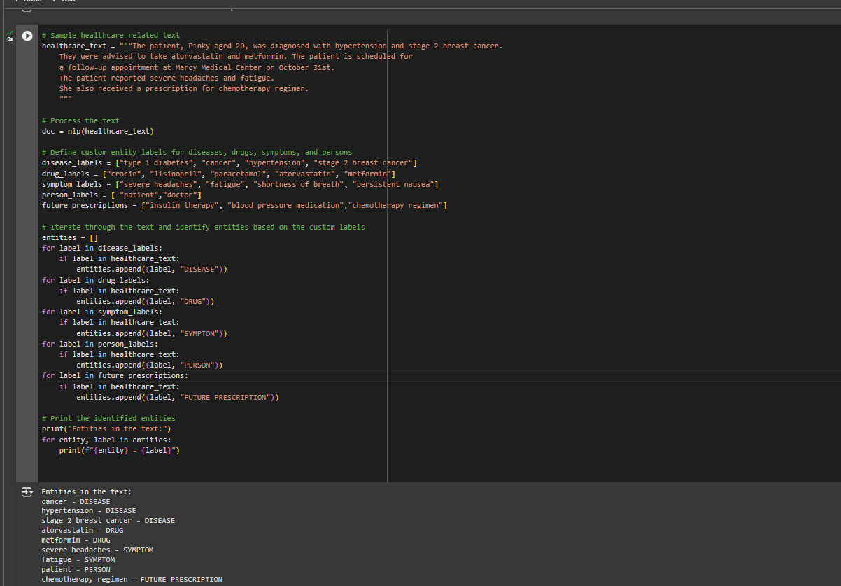

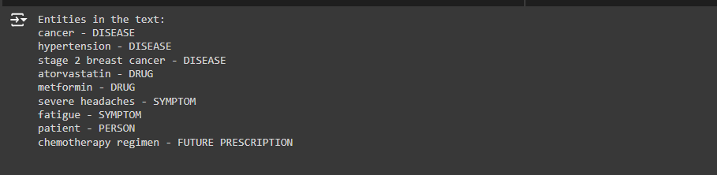

Google Collab link: <https://colab.research.google.com/drive/1Bx94kBDOKkO0D3_nMhlCH_kIj0E-Jwpk>

**Date: 24/10/24 Signature of faculty in-charge**

**Post Lab Descriptive Questions:**

Q.1 What is Natural Language Processing (NLP) and how is it applied to healthcare data?

Natural Language Processing (NLP) is a branch of artificial intelligence that enables computers to understand, interpret, and generate human language.

### Applications in Healthcare:

1. Clinical Documentation: Automates the transcription and organization of clinical notes.
2. Sentiment Analysis**:** Assesses patient feedback and satisfaction.
3. Clinical Decision Support: Provides evidence-based recommendations for patient care.
4. Predictive Analytics: Identifies patient risks and outcomes from unstructured data.
5. Medication Management: Monitors prescriptions and potential drug interactions.

Q.2 What are named entities in the context of healthcare NLP, and how can Named Entity Recognition (NER) be useful in medical texts?

Named entities in healthcare NLP refer to specific information extracted from text that can be classified into categories such as diseases, medications, symptoms, procedures, and organizations (e.g., hospitals).

### Usefulness of Named Entity Recognition (NER) in Medical Texts:

1. Information Extraction: NER helps identify and extract relevant medical terms from clinical notes, research papers, and patient records.
2. Data Structuring: It transforms unstructured text into structured data, making it easier to analyze and interpret.
3. Improved Decision-Making: By recognizing entities, NER aids healthcare professionals in making informed clinical decisions based on accurate and relevant information.
4. Research Insights: NER can streamline literature reviews by quickly identifying key concepts and relationships in medical research.
5. Enhanced Patient Care: It supports better documentation, tracking, and management of patient information, leading to improved outcomes.

Q.3 What are some common applications of NLP in healthcare, such as clinical decision support, medical coding, or patient sentiment analysis?

Common applications of NLP in healthcare:

1. Clinical Decision Support: Provides evidence-based recommendations to improve treatment decisions.
2. Medical Coding: Automates coding of diagnoses and procedures for accurate billing.
3. Patient Sentiment Analysis: Gauges patient satisfaction from feedback.
4. Predictive Analytics: Predicts patient outcomes and risks from unstructured data.
5. Medication Management: Tracks prescriptions and identifies drug interactions.
6. Research Assistance: Helps identify relevant studies in medical literature